

# Search Functionality Improvement Report

Project: MeDirect Equities Search

Created By: Dilan Meegoda

Date: 18th March 2025

# **Introduction**

The MeDirect webpage equities search functionality allows users to search and filter through a range of equities available on the platform. This feature is important for investors who are looking for stocks, sectors or financial details.

During my verification of the search feature, several useability and functional gaps were identified that could impact user experience and search efficiency. This report outlines key areas for improvement to enhance search accuracy, navigation, and filtering options.

# **Identified Issues and Suggested Improvements**

## Display ‘No Results Found’ Message

* **Issue:** When users search for an equity that does not exist, the results section remains empty, and no indication of a failed search or empty results.
* **Improvement:** Implement a **"No results found"** message when no matches exist.
* **Benefit:** Prevents user confusion and improves clarity.

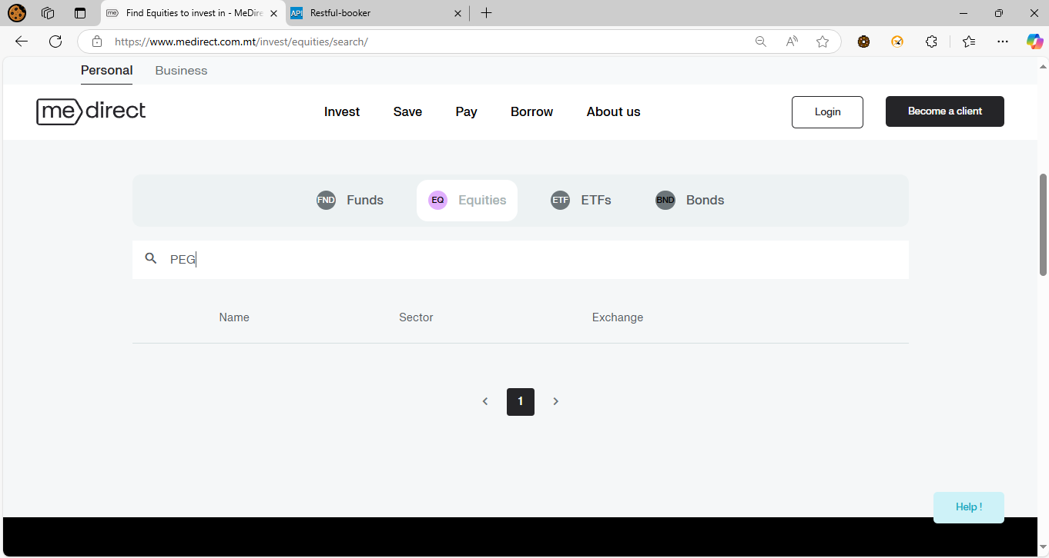

Figure 1: Missing "No Results Found" Message in Search Results

## Clarify Search Criteria

* **Issue**: The search functionality does not explicitly inform users that results are generated based on Name, ISIN, or Ticker.
* **Improvement:** Display a **search criteria note** below the search bar, such as:  
  *“*Search results are based on either Name, ISIN, or Ticker*.”*
* **Benefit:** Helps user to understand how the search works and improves accuracy.

## Add Search Type Scope Selection Option

* **Issue:** Currently, users can only enter a search term, but they cannot specify which scope they want to search it.
* **Improvement:** Introduce a scope selection next to the search bar allowing users to choose:
  + Scope one – Search by only name
  + Scope two – Search by only ISIN
  + Scope three – Search by only Ticker
* **Benefit:** Enhance the search scope and allows to refine search based on the requirement.

## Implement Sorting for Search Results

* **Issue:** Once a search is performed, and result generated the order of the results cannot be modified.
* **Improvement:** Add sorting options such as:
  + Alphabetical Order (A-Z, Z-A)
  + Sort by Exchange Type
  + Sort by Sector
* **Benefit:** Enables users to quickly find equities that match their specific investment criteria.

## Introduce Advanced Filters

* **Issue:** The search currently lacks of filtering options to refine results further.
* **Improvement:** Implement additional filter criteria, including:
  + Exchange Type (AMS, NYS, NON, etc.)
  + Sector Type (Media, Healthcare, Energy, etc.)
* **Benefit:** Enables users to quickly find equities that match their specific investment criteria.

## Improve Pagination Navigation

* **Issue:** Users can only navigate one page at a time, making it inefficient for large search results.
* **Improvement:** Implement quick jump pagination to allow:
  + One by one navigation
  + Jumping 5 pages forward and backward
  + Entering a page number to navigate directly
* **Benefit:** Provides better control for users searching through multiple equities.

## Prevent UI Shift During Page Navigation

* **Issue:** When switching pages, the UI scrolls to the bottom, requiring the user to manually scroll back up.
* **Improvement:**
  + Maintain the viewport position during pagination.
  + Add a loading indicator to improve user experience.
* **Benefit:** Ensures smoother navigation without unnecessary scrolling interruptions.
* **Video Capture:** [Link](https://drive.google.com/file/d/1DWu_DDeI0T2ix1G9EMTKVrv8SK5PjZHf/view?usp=drive_link)

## Retain Search Query and Results on Navigation

* **Issue:** If a user clicks "More information" button on an equity and then returns to the search page, the search query and results are lost.
* **Improvement:**
  + Retain the search term in the search box.
  + Ensure the previous results remain visible when users return.
* **Benefit**: This prevents user to re-enter search queries repeatedly.

## Display Total Search Result Count

* **Issue:** The current search results do not display how many equities match the query.
* **Improvement:** Add a **total results count**, such as:  
  Showing 1-20 of 134 equities.
* **Benefit:** Provides users with visibility on the total number of results and pages available.

## Fix Empty Page Generation Issue

* **Issue:** Sometimes, extra empty pages are created, even when no results exist.
* **Improvement:**
  + Ensure pagination only generates pages with results.
  + Hide navigation controls when no data is found.
* **Benefit:** Prevents unnecessary clicks and improves efficiency.

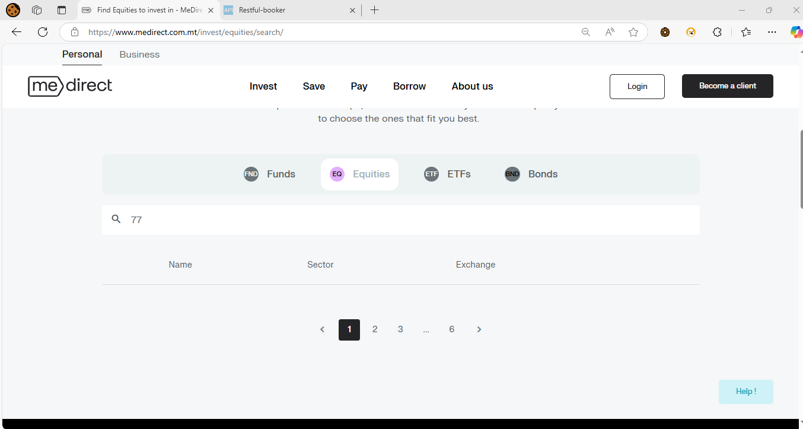

Figure 2: Pagination Without Search Results

## Handle Integer Search Queries Properly

* **Issue:** When searching with integer values, the system generates results, but often the number does not match Name, ISIN, or Exchange fields.
* **Improvement:**
  + Validate integer searches and return only relevant results.
  + If no direct match is found, display "No results found" instead of unrelated data.
* **Benefit:** Prevents misleading results and enhances accuracy.

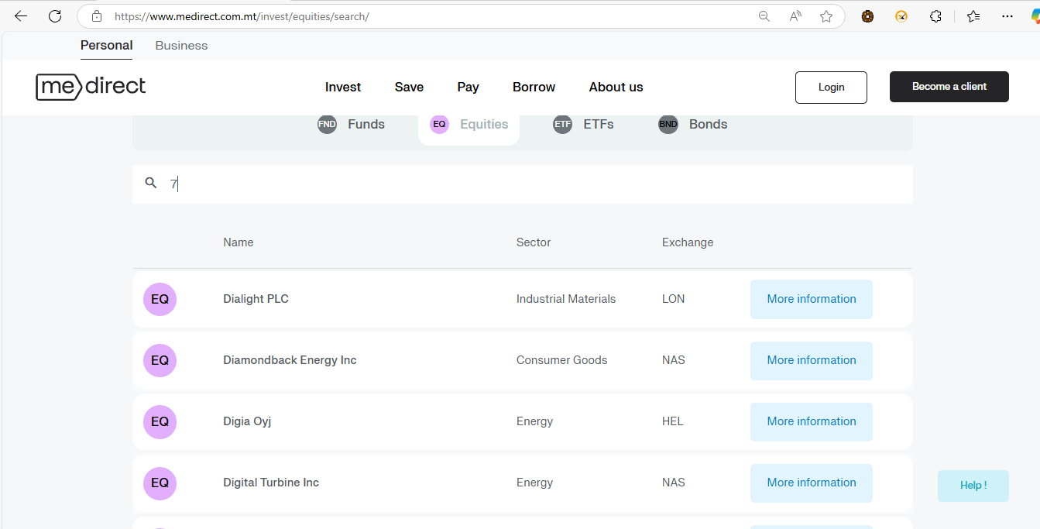

Figure 3: Search Query Not Matches the Results

# **System Configurations**

The following system specifications were used during the evaluation of the MeDirect Equities Search functionality:

* **Operating System:** Windows 10
* **Browser:** Microsoft Edge (Latest Version)
* **Screen Resolution:** 1366 x 768
* **Internet Connection:**
  + Type: Ethernet (Wired Connection)
  + Download Speed: 24.15 Mbps
  + Upload Speed: 5.65 Mbps